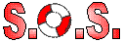
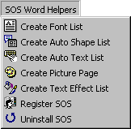This document has or will install the S.O.S. Word 97 Helpers. It will add a menubar to Word that looks like this;

With this document installed, you will be able to create;
- A list of all installed fonts
- A list of all autoshapes
- A list of all autotext and what they do
- A list of all pictures in a selected directory and all of it's subdirectories
- A list of all WordArt text effects.

Unregistered SOS Word Helpers do not have save or print capabilities. Click on 'Register SOS' on the 'SOS Word Helpers' menubar to get registration instructions.

